

2013 Live Green! Awards for Excellence in Sustainability –

About the awards:

- The Live Green! Initiative encourages all faculty, staff, and students to be fully committed to and engaged in making our campus, its operations, and initiatives as green and sustainable as possible.
- In celebrating the continued growth of the Live Green! Initiative, it is important to also celebrate individual and team excellence that brings the overall success we have accomplished as a university.
- These awards recognize Iowa State University faculty, staff, and students who are currently making an impact on the campus’ sustainability efforts by generating awareness and interest through initiatives that focus on teaching, research, outreach and/or operations.
- The Live Green! Awards for Excellence in Sustainability recognizes efforts across all aspects of the university, whether faculty, staff, student; individual or team efforts. The awards committee had a difficult task in choosing this year’s recipients, since the nominated projects and initiatives were both diverse and impressive. Winning projects were awarded based upon excellence in sustainability efforts and not limited by category.
- Nominations were evaluated within six areas: cultural impact, impact on natural resources, economic impact, transferability, legacy to the Live Green! Initiative and sustainability, and overall award merit.

2013 Live Green! Awards for Excellence in Sustainability Winners– BioChar Systems for Emerging Economies Team –
Members include: Matthew Kieffer, Juan Proano, Maria Aviles, Jyahao Leong, Diego Camargo, and Bernardo del Campo.
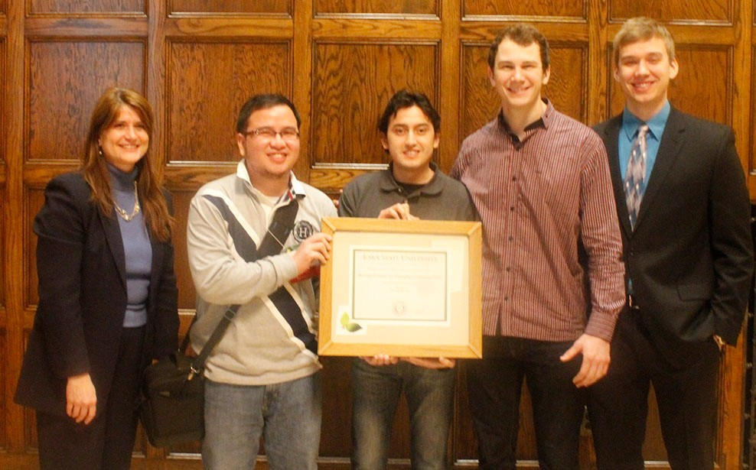

Biochar is a charcoal-like substance that has been shown to improve many properties in soil, such as organic matter content, water retention, aeration, infiltration, bulk density, cation exchange capacity, pH levels, and microbial activity. In addition, numerous field and greenhouse studies have shown that biochar amendments can increase crop yields. This group of students, in partnership with the non-profit organization EOS (Emerging Opportunities for Sustainability), has focused research efforts on building low-cost biochar reactors in Matagalpa, Nicaragua. The team’s vision is to provide more sustainable, efficient, and productive agricultural opportunities for locations with malnourished, water-deprived soil. Final prototype testing is currently underway with implementation set for June 2013.

David Correll –
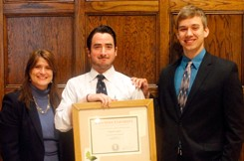

David, is the co-founder of ISU BioBus, a student organization with the goal of turning used vegetable oil from ISU Dining centers into fuel for CyRide buses. What started as a vision is now a reality with an annual average of 300 gallons of biodiesel being made from waste oil from Union Drive Marketplace and provided to CyRide’s bus #18. Besides providing a locally-produced fuel source for the Ames community, David’s leadership has ensured education and outreach opportunities for community residents and students from across Iowa through conducting tours of the Biobus’s laboratory and offering educational presentations for schools and organizations.

Research to Practice (R2P2) Team –

Members include: Ulrike Passe, Kerry Dixon-Fox, Sara Schmerbach, Isabelle Leysens, Zach Sunderland, Nate Wearin, Lu Wang, Daniel Lu, Mengyuan Ren, Justin Davis, Mati Ayana, Bryan Mock, Mark Jongman-Sereno, Alyssa Fallon, and Lucas Mutti.
From fall 2011 through spring 2012, a team of 15 Iowa State University students joined 35 other teams from higher education institutions in the US Green Building Council’s Research to Practice Program, focusing on opportunities to increase building energy efficiency. ISU’s team focused specifically on campus research lab buildings with two goals in mind: engaging undergraduate architecture and engineering students in hands-on research related to energy efficiency and from this research developing tools to increase campus and community awareness and engagement in building energy efficiency. Project deliverables have included the development of an Equipment Load Training Manual and an equipment efficiency comparative spreadsheet to offer a user-friendly tool to assist in equipment procurement decisions.
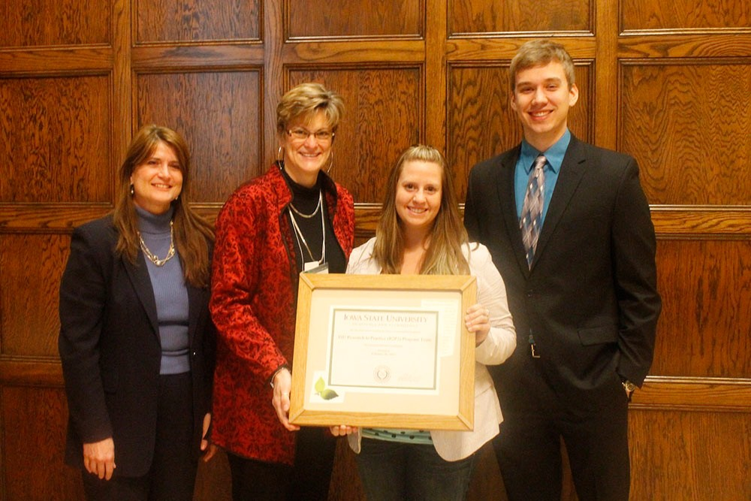

2013 Live Green! Awards for Excellence in Sustainability Nominees –

Organic Agriculture Program Team –
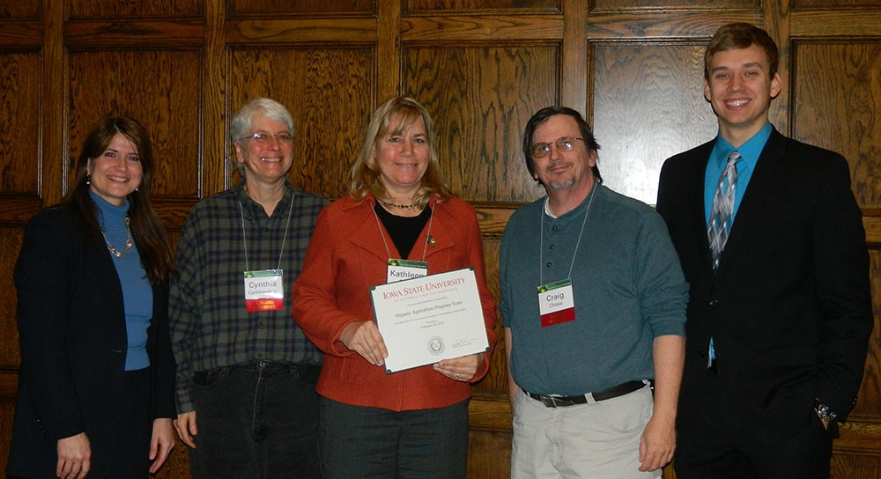

Members include: Kathleen Delate, Cynthia Cambardella, Craig Chase, Robert Turnbull, Kathy Rohrig, Bernie Havlovic, Randy Breach, and Mark Rasmussen.
The Organic Ag Program (OAP) is the first program of its kind at a land-grant and has become a model for other universities to adopt. OAP’s purpose is to help build a sustainable/organic agricultural industry in Iowa through: improving the energy efficiency of farming; helping producers and producer networks organize to coordinate production and marketing of sustainable/organic products; providing
technical assistance and educational opportunities to expand productivity and scope of sustainable/organic production; and facilitating linkages with consumer groups and supply chains to encourage marketing and consumption of sustainable/organic food. In addition, through original applied research, OAP has examined low-energy, renewable resource inputs, such as compost and other natural soil amendments that have a low-carbon footprint.

Daniel Kayser –
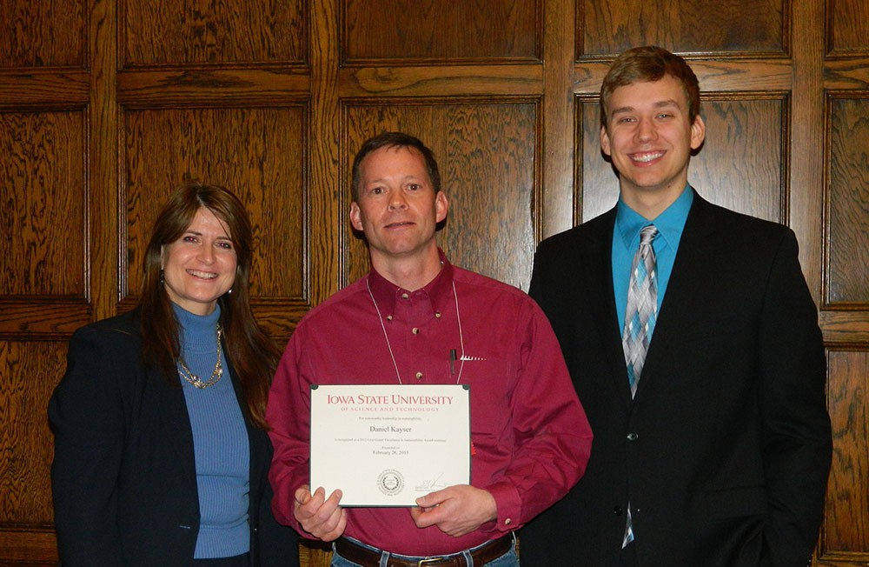

Daniel serves as the Chairman of the Ames Laboratory’s Environmental Management Systems Steering Committee. This committee meets monthly to set new ideas/activities toward pollution prevention, monitors the progress of those activities, and sets sustainable goals. Daniel’s active leadership has resulted in four significant Ames Laboratory sustainability projects over the past year: participation of Ames Laboratory in the National Bike Challenge, development of an Ames Laboratory Employee Commuting (ALEC) web application, increased commitment toward Environmentally Preferred Purchasing (EPP), and impressive growth and diversification of Ames’ Laboratory’s recycling initiatives with a 2015 goal of diverting 50% of non-hazardous waste.

Center for Excellence in Learning and Teaching Team – Online Student Evaluation of Teaching Team –
Members include: Ann Marie VanDerZanden, Allan Schmidt, Laura Bestler, Steve Mickelson, and Randy Dalhoff.
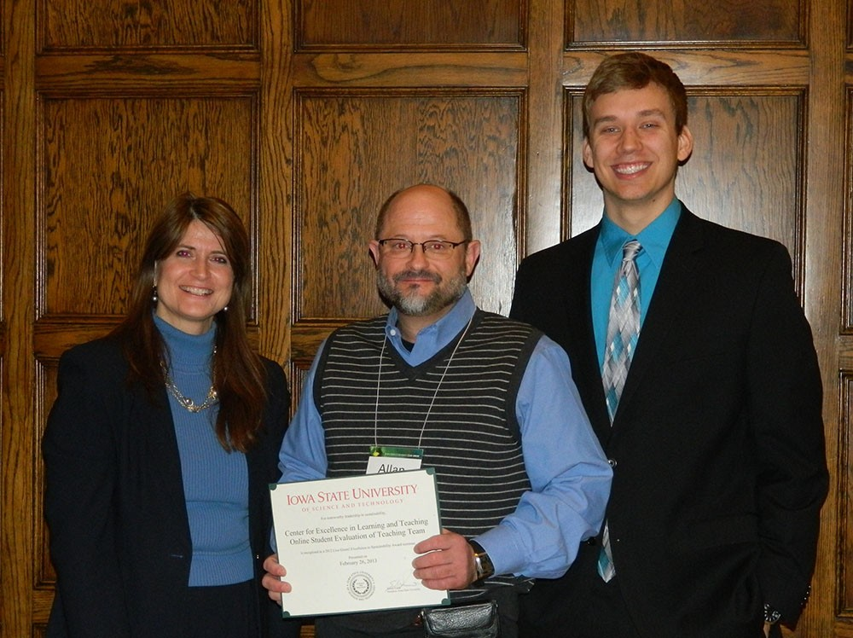

Online course evaluations provide a unique opportunity for departments to give instructors immediate feedback from the Student Evaluation of Teaching (SET). During the spring of 2011, a small group of departments volunteered to use the online course evaluation system that had been initiated by representatives from the Center for Excellence in Learning and Teaching (CELT) Advisory Board, CELT staff, and Informational Technology Services (ITS) with a primary goal of providing timely feedback for faculty and departments while also reducing paper use, easing data entry, and saving class and administrative time. Over the past two years, not only have all these goals been met, a higher evaluation response rate (with more qualitative feedback) has been achieved.

