2011 Live Green Awards for Excellence in Sustainability –

About the awards:

- The Live Green! Initiative encourages all faculty, staff, and students to be fully committed to and engaged in making our campus, its operations, and initiatives as green and sustainable as possible.
- In celebrating the continued growth of the Live Green! Initiative, it is important to also celebrate individual and team excellence that brings the overall success we have accomplished as a university.
- These awards recognize Iowa State University faculty, staff, and students who are currently making an impact on the campus’ sustainability efforts by generating awareness and interest through initiatives that focus on teaching, research, outreach and/or operations.
- The Live Green! Awards for Excellence in Sustainability recognizes efforts across all aspects of the university, whether faculty, staff, student, individual or team efforts. The awards committee had a difficult task in choosing this year’s recipients, since the nominated projects and initiatives were both diverse and impressive. Winning projects were awarded based upon excellence in sustainability efforts and not limited by category.
- Nominations were evaluated within six areas: cultural impact, impact on natural resources, economic impact, transferability, legacy to the Live Green! Initiative and sustainability, and overall award merit.

2011 Live Green! Awards for Excellence in Sustainability Winners –

Nadia Anderson – The Bridge Studio –
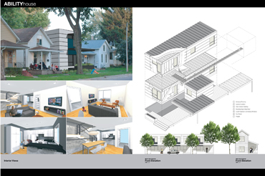
The Bridge Studio, initiated and directed by Nadia Anderson, is designed to create bridges between the often disconnected aspects of design, such as education and practice, architectural design and community building, and sustainability and affordability. Their work’s local impact benefits specific organizations, while providing models for sustainability and affordable design that can be used elsewhere. They have developed single family homes with the Community Housing Development Corp in Des Moines, the Iowa Finance Authority, and provided relief efforts in response to the flood impact in Cedar Rapids. The Bridge Studio developed an energy efficient prototype single home, which is now known as “The Iowa House”. The first “Iowa House began construction in fall of this past year, and includes contractor training on green building technologies. It is anticipated that these homes will use approximately 30% of the energy used by a typical new construction home of this size in Iowa. The Bridge Studio is the recipient of the National Council of Architectural Registration Board’s Grand Prize for Creative Integration of Practice and Education and the US Green Building Council’s Excellence in Green Building Education Award.
Rebecca Shivvers –

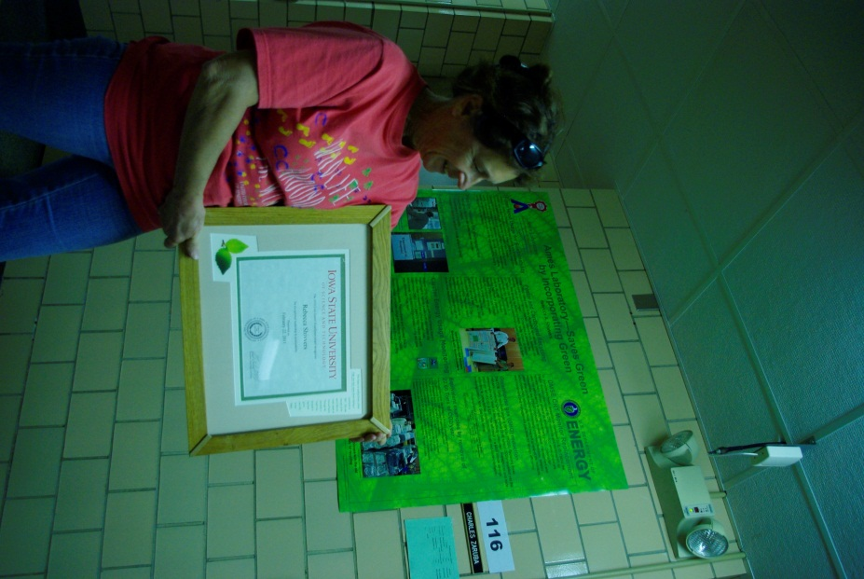
Rebecca Shivvers is a prime motivator for sustainability programs in the Division of Materials Sciences and Engineering and a catalyst for broader activities at the Ames Laboratory. The programs she has developed are effective and easily transferable to other areas of the Laboratory and University. Her infectious enthusiasm for energy conservation and general environmental concerns has resulted in great impacts at Ames Lab. She has initiated and coordinated the development of a Poster recycling and materials reuse program, the replacement of 63 CRT/LCD Displays for a projected annual savings in energy of $1,876, added a cardboard recycling program and an exhaust hood set back program which resulted in an impressive 55% reduction in 2009, and an additional 23% reduction in 2010 for significant energy savings. Rebecca imparts an internal drive to not only meet the targets set forth in specific programs, but to engage, challenge, educate and change the cultural of the Laboratory; from the Ames Laboratory Director to undergraduate research associates; from motion-controlled light switches to excessive paper use, all in an effort to make our workplace and most importantly, our staff, more environmentally conscious. She takes this commitment to Live Green! home to her personal life. In 2009, she installed a wind generator and is currently a net producer of energy on the grid.

2011 Live Green! Awards for Excellence in Sustainability Nominees –

Center for Biorenewable Chemicals Team Members – Tonia McCarley, Jon Harvey and Mary Ann Sherman –
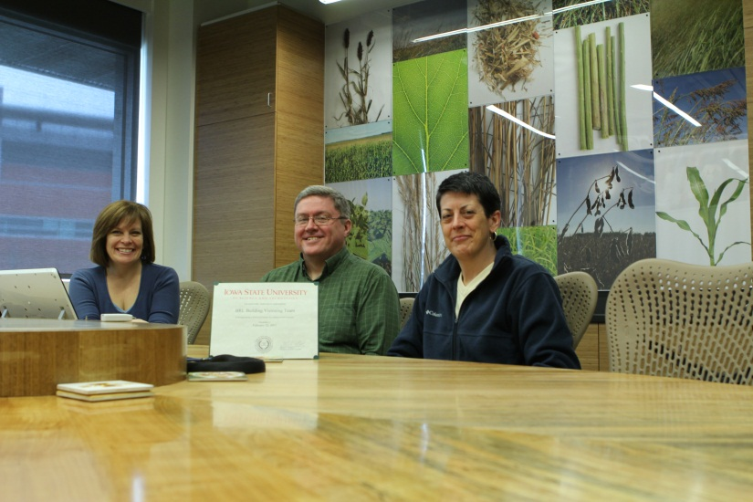
Given the type of work to be performed in the new Biorenewable Research Laboratory, it was critical that the design, construction and functioning clearly reflect sustainability. The functioning of the building can strongly be impacted by those who have a vision for the ultimate operation of the building, and this team worked as ‘user liaisons representing the needs of the building users and advocating for the incorporation of green or recycled materials throughout the project. In addition, they worked with the College of Design for unique art, conference table made from the TreeCYcle program, and in the advocacy and development of daily business practices of sustainability within the building (Green janitorial products, office supplies, and other practices).

Office of the University Architect –
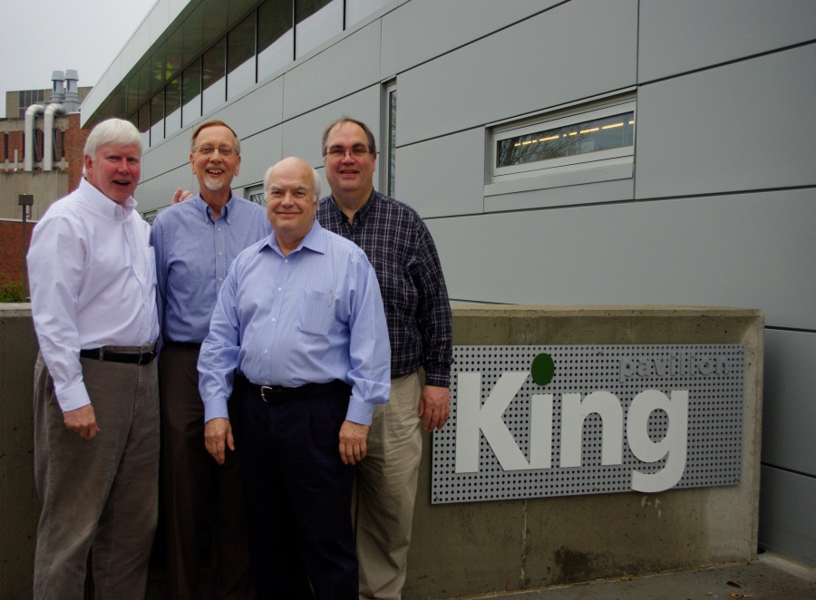
Dean Morton and the staff of the University Architect’s office have been spearheading the integration of sustainable design standards for new and remodeled facilities at Iowa State University years before its popularity became a national phenomenon. The office has challenged facilities staff, the campus users they partner with, the University Administration, and the design community to take a greener approach regarding the daily use of facilities, as well as their design and construction, The work of the University Architect’s office positively impacts not only the University’s Project Management Group, but also construction managers, clients, administrators, and design consultants. The work of this team has not only shown a spotlight on sustainable design activities at Iowa State University, it has helped lead others throughout the state into a deeper understanding and awareness of the need for a sustainable community.

Tom Lindsley – A to Z Library Sustainability Guide –
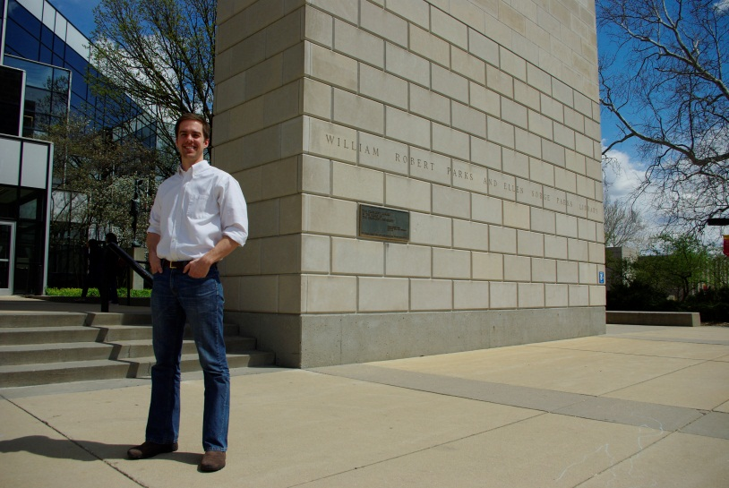
Mr. Lindsley (a student in the English PhD program in Rhetoric and Professional Communication) completed research on the visual rhetoric of college and university sustainability websites. His research resulted in a sustainability themed, online research guide for the Parks Library at ISU. The searchable database is an evolving collection of sustainability-related topics, useful for students and community members. This is the only guide of its kind in the nation. Tom’s work provided the platform for research to be completed and resources identified related to general as well as detailed sustainability topics. In being an online guide, ongoing access for clients, both on and off-campus, throughout the nation and around the world is able to be provided. Tom’s work has also reached diverse audiences, specifically interested in sustainable teaching and research, through several conferences in which his work has been highlighted.

