2009 Live Green Excellence Awards –

About the awards:

- The Live Green! initiative encourages all faculty, staff, and students to be fully committed to and engaged in making our campus, its operations, and initiatives as "green" as possible.
- Although having an initial focus on energy efficiency and conservation opportunities, the Live Green! Initiative encourages all efforts that support a sustainable future at Iowa State University and for our entire global community.
- In celebrating the first year of the Live Green! initiative, it is important to also celebrate individual and team excellence that brings the overall success we have accomplished as a university.
- These awards recognize Iowa State University faculty, staff, and students who are currently making an impact on the campus’ sustainability efforts by generating awareness and interest through initiatives that focus on teaching, research, outreach and/or operations.
- Although awards were initially focused within four categories: faculty, staff, student, and group or team, the review committee determined awards would be given based upon excellence in sustainability efforts and not limited by category.
- Nominations were evaluated within six areas: cultural impact, impact on natural resources, economic impact, transferability, legacy to the Live Green! initiative and sustainability, and overall award merit.

2009 Live Green Excellence Award Winners -

ISU Dining –
Long before the word sustainability came into Iowa State University’s every day vocabulary, Dining Services has worked to reduce waste, recycle, purchase local foods, and put other sustainable initiatives into practice. Tracking and challenging their efforts in accordance to a 21 objective sustainability matrix, Dining Services is committed to sustainable leadership. Among its larger initiatives are: Farm to ISU – a program started in 2007 committed to purchasing local foods and committing $450,000 to these purchases in 2008; Trayless Dining – starting in Seasons Marketplace in 2009 and resulting in all three residential dining centers going trayless; and Composting – since August 2009 diverting over 100 tons of materials from the landfill.

GreenHouse Group –
The GreenHouse Group began as a small group of students interested in implementing a recycling program for residence halls and student apartment communities. To date multi-commodity recycling has been established in 130 residence hall “houses” and all student apartment communities. In addition, recycling efforts have been so successful that a contract was secured with an outside vendor to process the impressive quantities of collected materials. Through partnership with ISU Department of Residence, this student group extensively planned, researched, and implemented every aspect of this program including logistics, training, marketing, and evaluation. The overall focus of the GreenHouse Group is not just recycling; it’s about involving students in making a difference that can also extend to other areas of sustainability including energy conservation and green living.

2009 Solar Decathlon Interlock Team –
In response to a call for proposals by the US Department of Energy, the Interlock team was formed in 2007 through the College of Design’s Green Design Research Collaborative. The team was only one of 20 teams selected from around the world to compete in one of the premier world events showcasing solar and sustainable technologies in residential construction. Through multiple cross-campus collaborations and courses, the team made up of 15 faculty members and over 200 students, developed, designed, and built an 800 sq ft, free-standing, solar-powered dwelling. The team competed within ten areas and finished in the top ten in four areas and 12th overall. This team’s efforts have engaged ISU students, faculty, and staff, as well as fostered lifelong awareness toward minimizing our impact on global climate change.

2009 Live Green Excellence Award Nominees -

University Composting Facility –
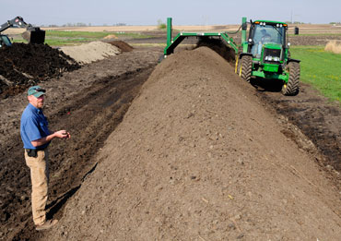
The University Compost Facility was originally planned only to serve as a component of the manure handling system for the new Dairy/Animal Science Education and Discovery Facility. Through efforts by the project team, the facility grew to one that could handle up to 15,000 tons of materials from a variety of university sources including animal facilities, biomass research, greenhouses, campus yard waste, and dining services. At full capacity, this facility will provide approximately 7,500 tons of finished compost for various university projects. The University Compost Facility and its partners; the College of Agriculture and Life Sciences, ISU Dining, and Facilities Planning and Management, have put into practice an industry-viable operation that is transferable to multitude of sources and entities.

Custodial Services –
Custodial Services initially developed The Green Cleaning Program to provide a safer work environment for custodial staff. Upon recognizing the importance and significance for meeting environmental and sustainable needs of the entire Iowa State University community, a Green Cleaning Policy was established that affirms commitment to environmental stewardship and sustainability. The Green Cleaning Program now comprises custodial decisions and actions as related to cleaning practices, supplies, equipment, and training. Due to its excellence in implementation and commitment to success, the Green Cleaning Program has become an integral part of meeting the University’s LEED sustainable building certification requirements and has been a valuable resource for other universities.

Extension –
In 2008, as an outgrowth of Iowa State Extension’s sustainability efforts, the Iowa-Missouri Green Team initiative was founded as a collaborative effort to train University Extension staff in sustainability issues. Priorities were two-fold; an internal focus on offices and staff living green, and outreach programming for external audiences. These priorities were based on an overall purpose of creating a multi-state program focused on developing teams and networks to deliver economic, social, and environmental education to achieve resource sustainability. Through these collaborative efforts, Extension has provided an effective and useful template to avoid duplication and strengthen efforts between state programs. To date over 60 staff have completed sustainability in-service training through this collaboration.

Library Sustainability Task Force –
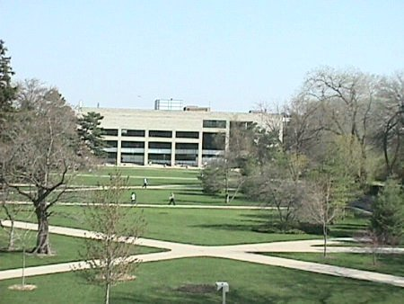
The Library Sustainability Task Force was founded to assist the University in attaining leadership in sustainability. Priorities were two-fold: assess work practices that supported judicious use of resources and strategically plan for the growth of an interdisciplinary “sustainable” collection. To initiate their efforts, the Task Force: developed a 4cs sustainability framework that was reflective of the library’s mission, completed a full assessment of the library’s green practices and the university’s needs, and completed a detailed report to inform strategic planning and support campus research and teaching. Because the Library serves the entire ISU community, the Task Force is focused not only internally, but externally in ensuring an influential and comprehensive sustainable approach.

Reiman Gardens –
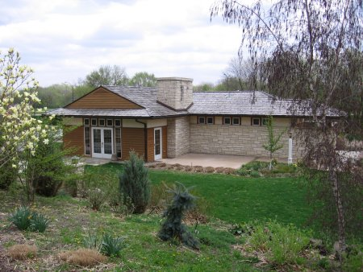
In 2007 while updating the Gardens’ master plan, staff suggested the current mission “To educate and enchant” was missing an important element, sustainability. From that moment, sustainability was not only incorporated into the mission statement, it was embraced into all the Gardens’ operations, maintenance, education, tour content, volunteer training, administration, and utility operations. In addition, each staff member full embodies sustainability in their individual work areas and responsibilities. Sustainability initiatives have included: becoming a “paperless” garden through electronic tours, e-vites and e-newsletters, participating in “Plant a Row for the Hungry” program that has provided 22,839 pounds of food to local food pantries, and planting a sustainable rose garden that resulted in 75% cost savings in comparison to a traditional rose garden.

