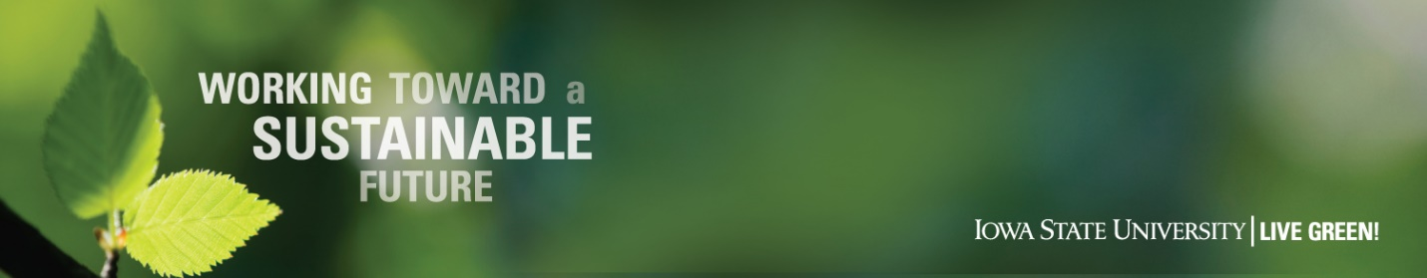
2019 Iowa State University Symposium on Sustainability:

2023 Iowa State University Symposium on Sustainability

Persistent Commitment Toward a Sustainable Future
February 20-21, 2023
Iowa State University, Memorial Union

Call for Artwork Submission Form – Deadline 2/3/22

General Information:

Title of Piece: Click here to enter text.

Artists Name, Year in School and Hometown: Click here to enter text.

Primary Contact Information:

Name: Click here to enter text.
E-mail Address: Click here to enter text.

Daytime Phone: Click here to enter text. Evening Phone: Click here to enter text.

Department Name: Click here to enter text.

Address: Click here to enter text.

City: Click here to enter text. State: Click here to enter text. ZIP Code: Click here to enter text.

Country: Click here to enter text.

Additional Information:

Please provide information about your artwork piece – media type, size of piece and display needs.
Click here to enter text.

Please provide an artist’s statement noting your inspiration for your piece and connections to sustainability. A summary of this information will be used in event marketing and education materials. (300 words maximum)

Click here to enter text.

Please indicate which category best represents your project:
Research:
☐ Green Product Development
☐ Energy Efficiency & Conservation
☐ Alternative Energy Sources
☐ Waste Reduction and Diversion
☐ Green Design
☐ Social Engineering
☐ Other (please describe) Click here to enter text.

Institutional Affiliation:
☐ Student
☐ Faculty
☐ Staff
☐ Other (please describe) Click here to enter text.

Please email your completed form to:
Noah Weber, Office of Sustainability
nrweber@iastate.edu

Questions can be directed to:
Merry Rankin, Office of Sustainability
515-294-5052 or mrankin@iastate.edu

Deadline for submission – 2/3/2022

