

2015 Live Green! Awards for Excellence in Sustainability –

About the awards:

- The Live Green! Initiative encourages all faculty, staff, and students to be fully committed to and engaged in making our campus, its operations, and initiatives as green and sustainable as possible.
- In celebrating the continued growth of the Live Green! Initiative, it is important to also celebrate individual and team excellence that brings the overall success we have accomplished as a university.
- These awards recognize Iowa State University faculty, staff, and students who are currently making an impact on the campus’ sustainability efforts by generating awareness and interest through initiatives that focus on teaching, research, outreach and/or operations.
- The Live Green! Awards for Excellence in Sustainability recognizes efforts across all aspects of the university, whether faculty, staff, student; individual or team efforts. The awards committee had a difficult task in choosing this year’s recipients, since the nominated projects and initiatives were both diverse and impressive. Winning projects were awarded based upon excellence in sustainability efforts and not limited by category.
- Nominations were evaluated within six areas: cultural impact, impact on natural resources, economic impact, transferability, legacy to the Live Green! Initiative and sustainability, and overall award merit.

2015 Live Green! Awards for Excellence in Sustainability Winners – ISU Extension & Outreach Human Sciences
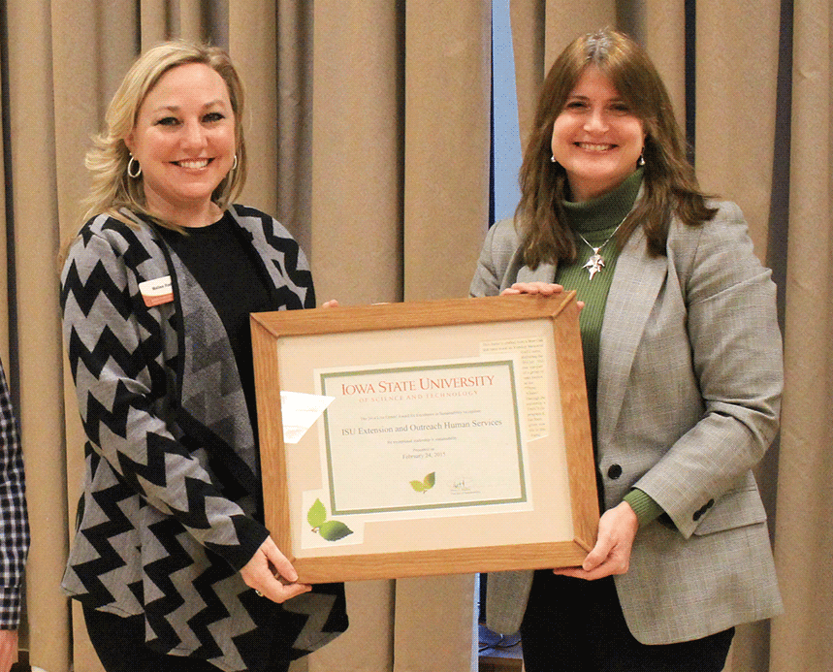

Led by Malisa Rader with Kristi Cooper, Donna Donald, Lori
Hayungs, Joy Rouse and Sandra McKinnon.

The team developed the Eco-Healthy Child Care online series. A team of Iowa State University Extension and Outreach human sciences program specialists recognized the opportunity to provide education and outreach to
child care providers and administrators on the topic of “greener” alternatives in their early childhood program. Research increasingly shows that the first years of a child’s life are extremely important in shaping their future health and development. Children are particularly vulnerable to environmental hazards for many reasons. Rates of certain kinds of cancer, developmental disabilities, asthma and
allergies—all of which have known or suspected environmental links—are on the rise in children.
Because many children spend significant periods of time in child care facilities, limiting exposures to environmental health threats in early care and education settings is essential. Through an online educational format, Extension specialists facilitated discussions, shared information and provided activities related to the EHCC checklist for endorsement. The team created the following website as the place to house all information for participants including handouts to print and session links 43 participants from around the state participated in the Eco-Healthy Child Care® sessions. Participants embraced the opportunity to operate a more sustainable program by purchasing more organic foods, recycling materials, reducing waste and finding new purposes for materials typically headed to the trash.

As one provider stated in their letter of support: “Because of the class we went through the daycare in search of anything that may be a problem such as the cleaning products, bug sprays, paints for the children etc. It was a real eye opener that things that might be fine for adults could be so toxic to young ones.”

ISU Bike Share Project: A Collaborative Project from the College of Design
Team leaders: Mark Kargol & Steven Herrnstadt with Erdem Selek, Jordan Maurice, Mani Mina, Jim Heise and Carlton Basmajian. More than 90 undergraduate students in Industrial Design, Community and Regional Planning, Mechanical Engineering, Electrical Engineering and Interior Design
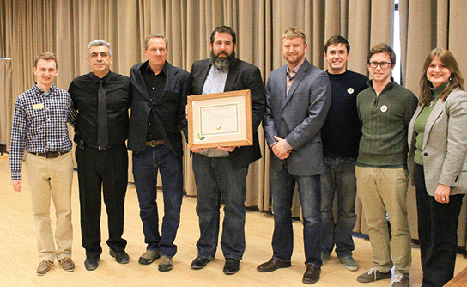

participated in this project.

The ISU Bike Share Project has grown from one Industrial Design senior’s capstone project to more than 90 students across campus enrolled in a cross-
disciplinary studio. It has not only included students from 11 different departments, but has also involved a cohort of faculty members and one graduate student from four departments teaching those students the complexities
of changing a transportation system. These students, which include members of Student Government and
its Executive Cabinet, have become more aware of the interwoven nature of transportation beyond simply designing a new bicycle and a place to check them out. They are seeing firsthand,how everything in such an environment is interconnected, including politics and human nature.

The intent was to develop a bike share system for Iowa State’s campus to improve sustainable transportation options, relieve congestion on the CyRide system, as well as increase the availability of health-oriented transportation with less carbon pollution and less fuel consumption.

Undergraduates designed three potential bicycles and beginning ideas of checkout systems, smartphone applications and more. The selected prototype design was further developed by the Industrial Design students while Mechanical Engineering students constructed a general prototype out of steel for initial riding tests so that adjustments could be made based on actual rides. The Mechanical Engineering students also designed a unique, simple and “fail-safe” locking mechanism to be incorporated into the docking stations. Computer Engineering students are creating the software and hardware for checkout, tracking, check-in and general system stats
and controls, and two Ph.D. Economics students are studying the placement of stations and the planning of that placement as it pertains to the viability of the Bike Share program.

This spring, the design for the bicycle will be finalized with specifications for manufacture, including complete designs with acceptable tolerances, finite element analysis and final fabrication blueprints to allow for commercial manufacturing. One will be made of steel alloy and another frame will be made of aluminum alloy for real world comparison. The docking station lock mechanism is designed and being finalized with a possibility of being patented. The team’s goal is to have 300 bikes manufactured and placed throughout campus in the near future.

